Coursework Resources

Content Covered over labs

1. Basic containerization techniques - Docker Labs

How this relates to the coursework

* 1. To create your own docker images
  2. Spin up containers from them
  3. Maintaining them in a registries

1. Docker compose and handling multiple containers

How this relates to the coursework

1. Use docker compose scripts and convert them to K8 scripts (Option)

([Kompose - Installation](https://kompose.io/installation/))

1. Prototype your services before bringing them over to K8
   1. Clickhouse on Docker-compose - [Docker Compose | ClickHouse Docs](https://clickhouse.com/docs/use-cases/observability/clickstack/deployment/docker-compose)
   2. Repository for Clickhouse docker-compose - <https://github.com/hyperdxio/hyperdx>
2. Kubernetes Labs

How this relates to the coursework

1. Gives the basic understanding of how to use kubernetes
2. Deploying applications on a cluster
3. Different Services and exposing applications.
4. Using Ingress Controller
5. Helm Deployments -> Helps with ClickHouse deployment on Kubernetes
6. Deployment of a static web application -> Directly related to the coursework

During labs we would be using a single node cluster on **Minikube** but for the coursework

you have a cloud native kubernetes deployment.

1. AWS - <https://aws.amazon.com/eks/> (Expensive than GCP)
   1. Installing a cluster - [Get started with Amazon EKS – eksctl](https://docs.aws.amazon.com/eks/latest/userguide/getting-started-eksctl.html)
2. GCP - Google Kubernetes Engine (<https://cloud.google.com/kubernetes-engine>) (Free Credit)
   1. Installing a cluster - [Install kubectl and configure cluster access | Google Kubernetes Engine (GKE)](https://cloud.google.com/kubernetes-engine/docs/how-to/cluster-access-for-kubectl)
3. Azure - [Azure Kubernetes Service (AKS)](https://azure.microsoft.com/en-us/products/kubernetes-service)
   1. [Quickstart: Deploy an Azure Kubernetes Service (AKS) cluster using the Azure portal](https://learn.microsoft.com/en-us/azure/aks/learn/quick-kubernetes-deploy-portal?tabs=azure-cli)
4. Oracle Cloud - [Kubernetes Engine (OKE)](https://www.oracle.com/ca-en/cloud/cloud-native/kubernetes-engine/)

**ClickHouse Resource**

1. ClickHouse Deployment on Kubernetes using Helm - [Helm | ClickHouse Docs](https://clickhouse.com/docs/use-cases/observability/clickstack/deployment/helm)
2. Integrating Clickhouse to the static web app using the js library - [ClickHouse JS | ClickHouse Docs](https://clickhouse.com/docs/integrations/javascript)

**Gotchas!**

1. AWS / Other cloud accounts of students get banned (And tends to happen closer towards the viva)

**Response: You cannot come and tell me that your account is suspended!   
 (No recordings)**

**Given the local option of demoing on minikube**

1. Cost
   1. Decide on the cloud provider early on
   2. Use local first and test everything and move to the cloud
2. Don’t fully understand the requirements of the assignment

**Student Questions and Answers**

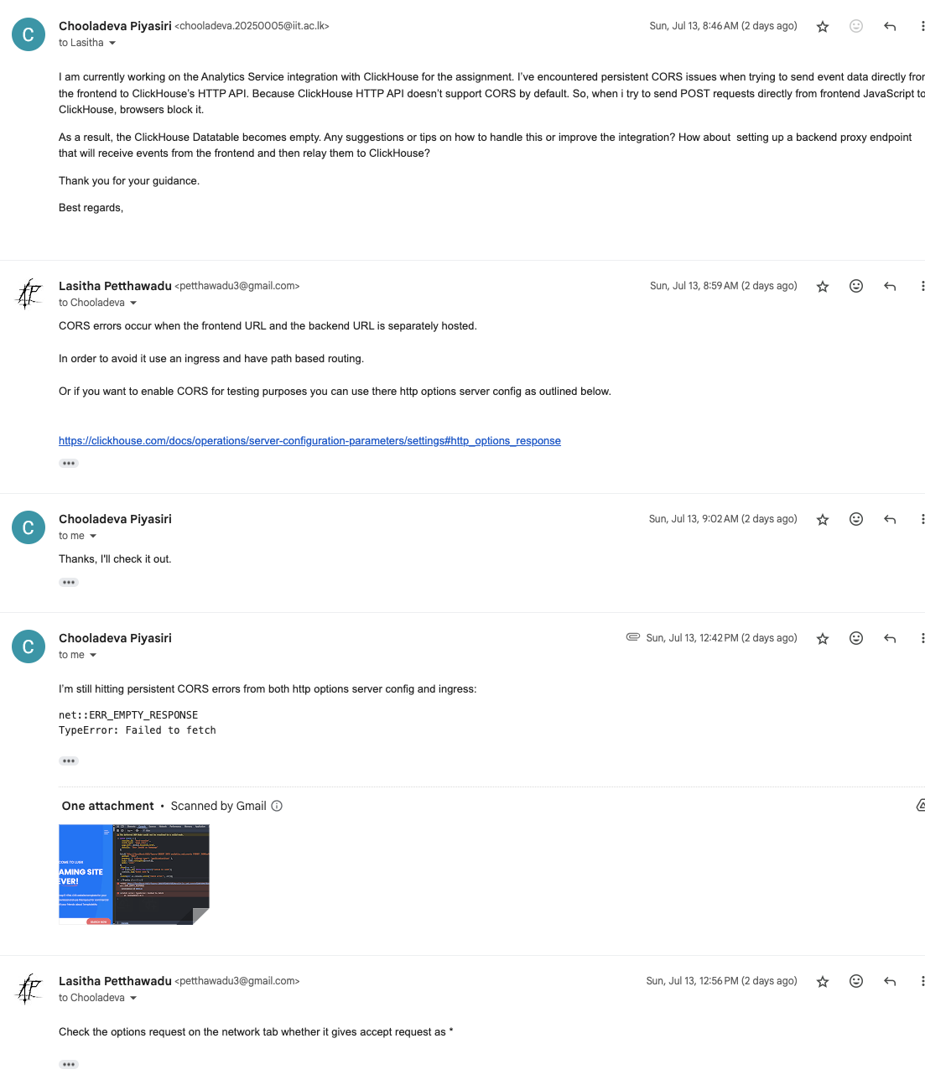

**Reference -** <https://clickhouse.com/docs/operations/server-configuration-parameters/settings#http_options_response>

